Project Number: | AD1006
Project Title: | EuroView - X.500 Directory Services for Administrations in Europe
Deliverable Type: | PU

Deliverable Number: | D3.1
Contractual Date of Delivery: | 05
Actual Date of Delivery: | 07 + 13
Title of Deliverable: | User Requirements Report
Workpackage contributing to the Deliverable: | WP3
Nature of the Deliverable: | RE
Author: | Angel Inglada, Luis Fernandez, Phil Wynn, Damy Mahl, Andrew Findlay

Abstract | This document describes the methodology used to obtain information from potential end-users of electronic directories inside public administrations. Some conclusions are drawn from the answers obtained and these are used to help define the special requirements that need to be fulfilled by an X.500 directory service for administrations.
Keywords
Classification

Name of Client:
Distribution List:
Authorised by:
Issue: | 2.0
Reference:
Total Number of Pages: | 56
Contact Details:

Table of Contents
PART I Title Page
Part II
Document Control
Executive Summary
PART III
1. Approach to the survey
1.1 Aims and objectives
1.2 Characterisation of the sector of public administrations.
1.3 Criteria for targeting the survey.
1.4 Overview of the selected targets.
1.4.1 Germany
1.4.2 Spain
1.4.3 United Kingdom
1.5 Description of the methodology for the Survey.
2. Introduction to the questionnaire.
3. Analysis of the answers
3.1 User Organization
3.2 Office automation tools
3.3 Electronic mail
3.3.1 Products
3.3.2 Configuration
3.3.3 Usage
3.3.4 Integration
3.4 Networking
3.5 Existing links with other entities
3.6 Categories of organization to include in the directory service
3.7 E-mail traffic load
3.8 Directory data
3.9 Existing directories
3.9.1 Directory types
3.9.2 Opinions
3.9.3 Access method
3.9.4 Functional search
3.10 Service conception
3.10.1 Different views
3.10.2 Security requirements
3.10.3 Access to the directory service
3.10.4 Response time and availability
3.10.5 Integration with other tools
3.10.6 Data maintenance procedure
3.11 Miscellaneous
4. User requirements reference
4.1 Directory Data
4.1.1 Typical content of the directory
4.1.2 Different views
4.1.3 Data maintenance
4.2 Connectivity
4.3 Directory usage
4.3.1 Facilities
4.3.2 Integration
4.3.3 Availability and response time
4.4 Legal and security requirements
5. Appendix A. Organization and People
6. Appendix B. Presentation of the Project
7. Appendix C. Questionnaire
8. Appendix D. Review of answers to the questionnaire.
8.1 List of Interviewed Organizations
8.2 Identification data
8.3 Office automation tools.
8.4 Electronic mail
8.5 Networking
8.6 Existing links with other entities
8.7 Existing directories
8.8 Service conception
9. Appendix D. Glossary

- Part II
- Document Control
Issue Number | Issue Date | Reason for Change
2.0 | 10/01/97
- Executive Summary
The EuroView survey started by identifying a set of likely directory-using organisations within the administrations of several European countries. Initial contacts were established within these target organizations. An agreement was then reached to hold the necessary interview required for completion of the questionnaire. A short presentation on the objectives and methodology of the EuroView project was given immediately prior to interview. Reports were generated for each questionnaire completed. Any issues raised that were not addressed by the questionnaire were noted.
The completed reports were collated, answers were analysed. This resulted in the statistical information and associated comments presented in Section 3 of this document.
Many important points arose from analysis of the results. Some of the most important are mentioned here.
From the networking standpoint it was clear that most organizations had a LAN connecting most of their sites internally. Additionally the protocol used was most often found to be TCP/IP. Whilst there is still significant use of X.25 for wide area interconnection, its use is diminishing in favour of Internet protocols.
Links between different organizations are well identified. However, the corresponding requirement for the interchange of documentation and e-mail for each of these links is not so clear. Each interviewed organization stated that the first external entries they would like to find in the directory would represent, obviously, those organizations it communicates the most with. Overall, these tended to be the centralized and high level organizations such as national administrations, European institutions with regional and local government following.
Many users currently have an electronic directory of some description already in service. In most instances this is a simple proprietary implementation. Despite the fact that these are not X.500 based, and therefore lacking in distributed functionality and interoperability, they have the great advantage of being tightly integrated with the e-mail system currently in service. Any directory tool supplied by EuroView will have to approach a similar level of integration.
Requirements were also identified for what sorts of data the directory should hold. The following pieces of information were deemed essential: name, organization name, e-mail address(es), postal address, telephone number, fax number and organizational role.
Due to the private nature of much of the information that might be put in a directory it was also apparent that more than one view of directory data may be necessary: a private internal view containing full personal identification data and an external view containing functional and role entries.
In conclusion, the requirements identified in this document are similar to those placed on existing X.500 directories.
- PART III

Approach to the survey

Aims and objectives
The overall objective of project EuroView is to promote the use of X.500 based electronic directories in the world of European administrations. The first task undertaken was a survey of potential users of EuroView services. The main aim of the survey was to get a picture of user requirements and also of current attitudes toward the proposed technology and directory services in general.
There are three clear objectives to be achieved by the survey:
- Before the construction of the pilot service, the requirements of future users must be collected and studied to ensure that any subsequent plans cover their current needs.
- Assistance in the generation of a handbook covering (amongst other things) the installation, maintenance and use of electronic directories inside administrations. This requires a definition of those problems currently faced by the public employee that are to be solved by the use of such technology. The user requirements for the service follow from the problems perceived during the course of the survey.
- The survey is a good way to establish contacts inside a group of potential users, hopefully leading to some promotion of the project and the technology.
As EuroView is a pilot project, the overall aim is not only to develop a directory service but also to analyse carefully the attitudes of administrative users in relation to the service. As well as the basic requirements of the service, information should be sought on the various advantages and disadvantages that a user may perceive from electronic directory technology in general. End-users were therefore confronted with issues such as quality of service, security, integration with existing tools and service evolution and enhancement.
Another important part of the survey was to analyse general levels of end-user technology awareness and usage. Hence feedback was obtained on the use of office automation tools (specifically e-mail), the use of existing directories (and the importance placed on them) and the general attitude towards these relatively new tools.
To summarise, the following information was sought:
- Identification of user organization (activity, number of employees and potential users, number of sites, organization scope).
- Organizational resources (general background information, information technology resources and communication resources).
- Commitment to integrating new communication facilities (namely e-mail) with ordinary work procedures.
- Information on any specific mail and directory systems currently in service and levels of usage.
- User opinion of the new service, specifically about its utility and associated commitments. Advantages and disadvantages .

Characterisation of the sector of public administrations.
Prior to a discussion on the criteria used to select target organizations for the survey, it would be beneficial to mention some of the common characteristics of public administrations in Europe, noting that these features have a direct influence on the selection of target organizations, and on the questions asked.
The public administration is a sector comprising of several thousand organizations and employing several million workers across Europe. Its share of the national product of each country is around 20%.
It is well accepted that the public administration is currently technologically behind many other sectors (namely the Industry and Services sectors).
Information Technology has been recognised as a key factor in the modernisation of public administration and many initiatives have been undertaken in order to promote the use of these new technologies. In some cases a service based on a new technology is initiated from scratch and in other cases advice and redirection on an existing service is given.
A list of these initiatives would include EPHOS (European Procurement Handbook of Open Systems), Euromethod and National Performance Review in the USA.
As stated the administrative sector is a very large one. Advances in IT usage are often driven by umbrella organizations or organizations otherwise acting in a directive role. In this sense the sector does not act as a free market, and follows a hierarchy of power. However, the theoretical authority of some organizations to issue mandatory directives is opposed by the inertia that this sector has and also by economic restrictions.
The economic aspect is also relevant to this survey, as it is one of the first restrictions applied to technology development in administrations. This fact is well known and is supported by the survey results.

Criteria for targeting the survey.
Bearing in mind the information presented in the previous section, it is important to define the criteria used for the selection of target organizations and the mechanism of the selection itself.
The primary aim was to select a diverse and representative set of users from the huge number of public administrations in Europe. The criteria that played some role in the selection are listed together with explanatory text.
- Interest in use of e-mail for information exchange.
This criterion was important since organizations with an interest in e-mail are more likely to be aware of the problem of people trying to establish contact with unknown recipients.
Answers from such organizations would reveal the real requirements and concerns for the service as they may have considered the relevant issues already.
- Horizontal organizations used to promote IT within public administration.
In each country there are many organizations used to promote the use of IT within public administration. These are key targets since they should already be aware of the technology and have plans (short or long-term) for its implementation within public administration.
Another benefit of such organizations would be their potential use as a ‘gateway’ to the many organizations they represent or advise.
- Familiarity with office automation tools.
This is an important criterion for those administrations not currently using e-mail. If an organization is not familiar with office automation tools, then it might be difficult to determine the advantage they would gain by using a electronic directory.
It has been noticed, however, that the PC revolution has reached public administration and that the use of word processors is commonplace. Advanced use of these tools (such as spreadsheets or document templates) can be seen as an indication of a higher level of integration with such tools.
- Use of networks
Since electronic directories are accessed through networks and related to e-mail, familiarity with networking issues such as connectivity problems and performance was required.
It was noted that many administrations are managing or launching a Local Area Network, and improving connectivity between sites.
- Heavy mail traffic, preferably with organizations in other countries.
Organizations with a strong dependence on mail would probably be more able to perceive the advantages of electronic directories.
- To be currently maintaining some kind of directory.
This would ensure the user’s awareness of the advantages of X.500 directories.

Criteria such as size, number of sites and national/local character were not considered essential for the selection process. In fact it was considered beneficial if the coverage included small, medium and large organizations, with scope from local to European.
After identifying the selection criteria, secondary issues were considered. These were areas such as proximity to a project partner, existence of previous contacts with a project partner and the willingness of the organization to dedicate some effort to the interview.
It should be recognized that the project partners are not in a position to demand the effort required to hold the interview and complete the survey form. Some organizations have not answered some questions fully, and have expressed difficulty in obtaining some data (e.g. e-mail traffic statistics), and this has had to be accepted by the project partners.

Overview of the selected targets.
The selection process eventually resulted in interviews with eighteen target organizations and the establishment of several interesting contacts.
This section presents some comments about the position and suitability of the target organizations within each country considered. A full description of these organizations is presented in Appendix A.

Germany
Auswärtiges Amt (German Foreign Office) has accepted to join the Euroview user group and participated in the survey. Their activities include the co-ordination of communications between the EC and NATO for the rest of the German administrations.
The Kommunale Gemeinschaftsstelle (KGSt) is an advisory organization, formed by local authorities in Germany and Austria. Its aim is to promote the use of Information Technology inside the public management. In this respect KGSt is a useful and appropriate user to survey (and ask to join the EuroView User Group) in its role of representing several thousand offices of local governments.
Contacts with the Ministerie Binnenlandske Zaken in Netherland were established. They have managed a pilot X.500 service for two years and therefore have real experience in this area. They did not shown enough interest in the survey, however, to be of much use.
The LVA Rheinprovinz (Regional Pension Insurance Institutes) were contacted for the survey. This contact failed, however, due to the unsuitability of the original contact. This has now been solved, and positive co-operation has been established. It is hoped that this organization will join the User Group shortly.
Other organizations contacted with some degree of success are the Innenministerium Baden-Würtemberg (currently managing various X.500 projects), the KoopA and the Verband Deutscher Rentenversicherungsträger. Dialogues are currently in progress with these organizations with a view to further enriching the EuroView User Group.

Spain
The Ministry of Public Administrations (MAP) has been a member of the EuroView User Group since the start of the project. They are in charge of the promotion and organization of e-mail and X.500 technology for the whole of the Spanish administration.
The ITSMO project, promoting the use of X.400 inside the administration, comprised of 12.000 mailboxes in Nov 95. This project is managed by the Computing Council (Consejo Superior de Informatica, CSI) with MAP as a participant. Hence the CSI itself is participating in EuroView through MAP.
Through the ITSMO project, it was possible to reach the managers of each participating organization. These organizations were considered good targets for the survey as they matched the selection criteria quite well.
Many ministries were represented in this group (Economy, Public Works, Foreign Affairs, Culture) as well as some regional governments (Balearic Islands, Basque Country, Valencia). The ministries gave personal interviews to complete the survey whereas the regional government answered the questionnaire by mail (providing any additional information by telephone).
The Ministry of Social Affairs (now Ministry of Work and Social Affairs) is also a member of the EuroView User Group. They have an efficient e-mail structure where 50% of information is internally interchanged using e-mail and some use is made of proprietary electronic directories.

United Kingdom
The Ministry of Agriculture, Fisheries and Food (MAFF), and more specifically its Information Technology Directorate, has answered the survey, and expressed their interest in participating in the project. They are now managing a directory service with more than 90 DSAs.
The CCTA (Central Computer and Telecommunications Agency) is a soon to be privatised agency that provides “best practise” consultancy on information services and technology to government agencies. It is this aspect that makes the CCTA a very interesting organization to interview.
Initial contacts have been established also with Hampshire County Council. They are a large organization, with about 16000 computer users at present spread across many sites.
Hampshire IT services have evaluated several DSA suppliers and are likely to buy an ISODE-based product in the near future. They plan to have about 16000 entries loaded by mid-December and would like to connect to EuroView. The second stage of the project would cover hundreds of associated organizations working in their part of the country and would probably result in a further 100000 entries.

Description of the methodology for the Survey.
Two different survey methodologies were adopted with the methodology selection depending on the way in which the questionnaire was answered - a personal interview conducted by one of the partners or the questionnaire completed by the end-user and sent by post.
In the case of a personal interview, the collection of information would proceed as follows:
Prior to the interview:
- A telephone conversation is held with the end-user where a brief introduction to the project is given and an interview is requested.
- A letter is subsequently sent to the end-user proposing an interview and outlining its agenda. The letter would also include a short EuroView introduction (refer to Annex 2). In some cases the questionnaire would be included, enabling the end-user to become familiar with it prior to the interview.
During the interview:
- A short presentation is given on the survey methodology adopted.
- The questionnaire is discussed.
- Any questions the end-user has are answered, stressing any links between their problems and EuroView solutions.
- A discussion is held on the current status and requirements of the organization.
In the case of a posted questionnaire, the collection of information would proceed as follows:
Prior to sending the questionnaire:
- A telephone conversation is held with the end-user where a brief introduction to the project and survey methodology is given and participation in the project is requested.
- A letter is subsequently sent to the end-user containing a short EuroView introduction (refer to Annex 2) and the questionnaire.
Whilst completing questionnaire:
- EuroView consultants are available on the telephone to clarify any confusion the end-user may have on the questionnaire or the project in general .
In each of the scenarios outlined above, a report was produced summarising the conclusions drawn from the contact made with the end-user in question.

Introduction to the questionnaire.

In order to ease analysis of collected information, the questionnaire contained some yes/no answers and some simple statistical questions.
The questionnaire also had to provide detailed notes on the discussion held in order to provide the project with background information and give guidance for further work.
The main areas covered by the questionnaire were :
- Identification data.
Information used to locate the organization: name, address, size (sites, employees), etc.
- Technological environment.
Questions about the use of computer tools, especially e-mail.
- Networking.
The structure of the network: protocols and connections inside and outside the organization, current usage of these connections.
- Links with other organizations.
Questions concerning existing links and mail traffic with national and European peer entities.
- Existing directories.
Questions concerning the use and structure of existing directories and any perceived improvements.
- Service conception.
Any possible requirements of an X.500 directory service.

Analysis of the answers
In this section the data obtained from the survey is analysed. Comments are made on the questions and answers, and some statistical summaries are presented to support the conclusions.
Appendix C presents the questionnaire used in the survey. It presents the questions in various groupings, and these groupings are used in this section for consistency.
All the questions and answers of the survey are listed in the tables of appendix D. All organizational acronyms are presented in Appendix A.

User Organization
The survey included organizations with an international scope down to local councils.
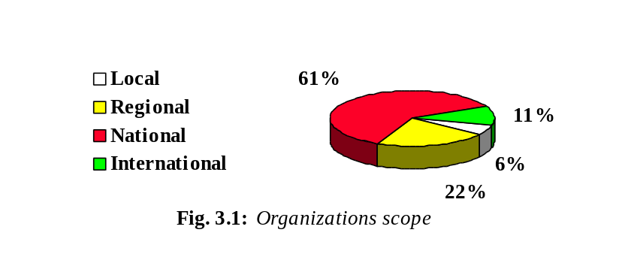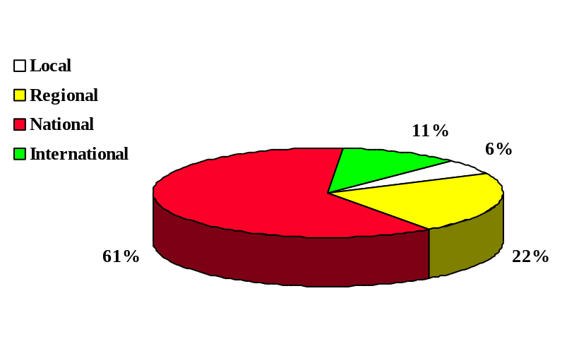
As criteria like size and number of sites were not considered relevant to selection, a wide range of organizations were surveyed (from the 53 employees of the KGSt to the 80,000 of the MW and from the 2 sites of several organizations to the 675 sites of the MEH).
The number of employees and sites or buildings do not depend on the geographical scope of the organization. Thus, a local organization like MW has 150 buildings while several national character organizations have only 2.
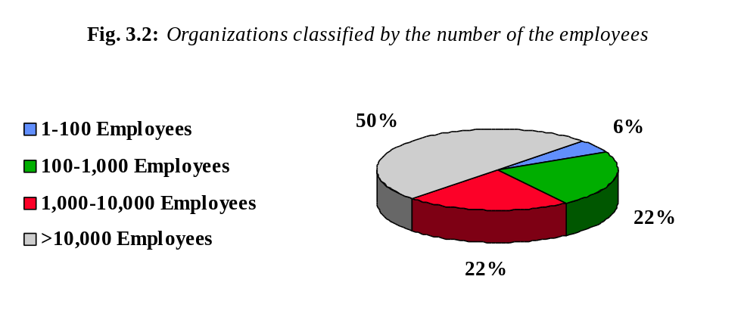
The number of sites in an organization and their geographical distribution does not necessarily imply anything about its internal connectivity. A single Directory server can service all sites (see ‘Networking 1’).
The MEH (675 buildings across Spain) does not have all sites connected in a common way, whilst the AA (250 sites across the world) does (but only for its central unit in Bonn and not for missions world wide). A similar structure exists in the Spanish MAE.
The ratio of current e-mail users to potential users shown by many Spanish organizations is far from ideal. There is only one (the SEUE) which has e-mail for one 100 per cent of users.
The situation seems to be different in other countries where usage is 100 per cent in each case (KGSt, AA, CCTA, MAFF).

Office automation tools
Use of PCs and word processors is very common. Spreadsheets and other tools less so. In all organizations, most documents exchanged (internally or externally) are generated by office automation tools.
This does not imply that these documents are now transferred by e-mail. For instance, as expressed in the KGSt answer, “Most information provided by the KGSt does not originate there and is currently only available in paper form. Most of this information is generated by office automation tools, when looking to the source of information.”
The use of predefined formats and/or templates is quite extensive (official documents, letters, facsimiles, etc.). This can be taken as an indication and measure of the advance in office automation. The use of templates indicates high familiarity with these tools, and this in turn may imply stronger requirements for the new electronic directory access tool than have been anticipated, especially in terms of integration.
The next chart displays statistics on the familiarity of the end-users with these tools:
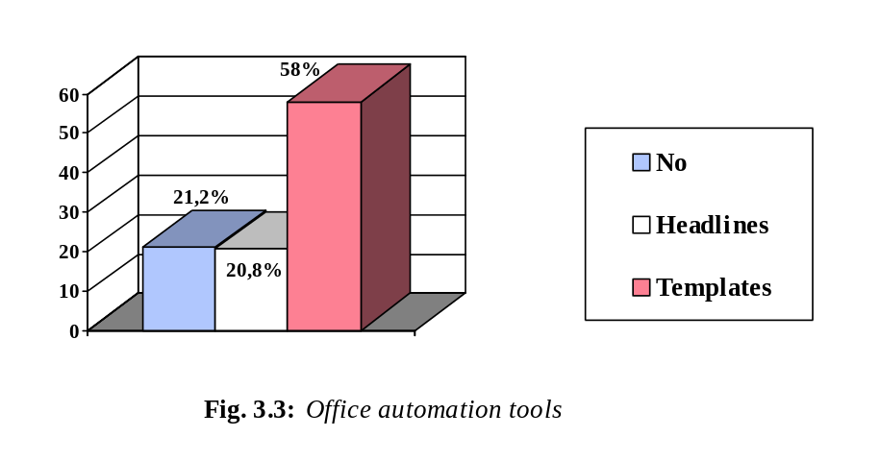

Electronic mail

Products
There is a wide range of products in use in European administrations. This is not strange, because each national market has been penetrated by different products from different vendors and only some large companies are represented in more than one country.
A list of e-mail products and companies is presented below, indicating the number of users of each tool.
PRODUCT | PERCENTAGE | COMMENT
Isocor | 31% | Company from the USA, with many kinds of OSI products, including X.400 MTA, UA and X.500 DSA.
NetTel | 21% | British company, many products for X.400 and X.500. Well positioned in Spain.
HP-Openmail | 16% | US company (Hewlett-Packard). Proprietary mail product with MTA’s, & interface to X.500
Osiware | 16% | Full OSI products, MTA’s , UA’s and RUA’s
ICL | 11% | British company, X.400 & X.500 products
Osilink | 5%
DX-Mail | 5% | SW for X.400 MTA’s and UA’s, produced by EuroView project co-ordinator (Dr.Materna)
Openpath | 5%
Retix | 5% | OSI products.
DEC-All-in-one | 5% | Digital’s tool for office automation, including e-mail.

Most mailers use X.400, with SMTP gateways, to access the Internet world. Only one organization uses SMTP mail directly, with freeware software.
Some Mail User Agents offer simple directory functionality. In most cases the directory is implemented a basic list of name-address pairs, displayed as a whole for sequential browsing and providing one simple string-search function. The user can select an entry in the directory, and the electronic address of the selected entry is placed in the address field of the message being composed. These directories are usually managed by the UA or MTA software and often have a restricted database size. Facilities for importing data from other databases and querying mechanisms are very limited. They are useful where e-mail has been recently introduced, but are difficult to manage when the number of entries increases.
Nevertheless, the simple directories available indicate the requirement for some level of directory service and are a good way of demonstrating to users the advantages of the more functional X.500 directory.

Configuration
The number of MTAs is not determined by the number of users but more by connectivity factors. In most cases the MTA covers a whole LAN, which in turn is usually a whole building or site. LANs are present in administrations almost as often as PCs and word processors, although full inter-LAN connections are less frequent. In many cases, a LAN has an e-mail connection to the outside world, but no full network connection to other LANs.
The platforms used for MTAs are very different in size, from PC-DOS to DEC-minis (DOS users want to move to 386 Unix (SCO)). The conclusion drawn from the interviews is that the number of mailboxes and UAs does not effect the power of the MTA. The main factor here seems too be the real level of e-mail traffic. The future use of a directory service would probably be related to the use of e-mail.
It is worth mentioning that some MTA products use X.500 technology, with the implementation provided only as a functional test bed. Deviations from the standard can often be found in such cases. It would be interesting to analyse the possibilities of using such X.500 services to either implement a local DSA or connect to existing DSAs for directory consultation and, possibly, enhancing integration with local e-mail software and smoothing the installation process.

Usage
The basic usage of e-mail is clearly for interpersonal messaging (on a one-to-one or one-to-many basis and in free text format). Many organizations have pre-composed headers and/or official signatures.
Use of file attachments for document and data delivery is widespread. Some have additional role/functional mailboxes related to a department and mapped onto a delivery list for people in the department (or perhaps a secretary distributes the received mail in the department).
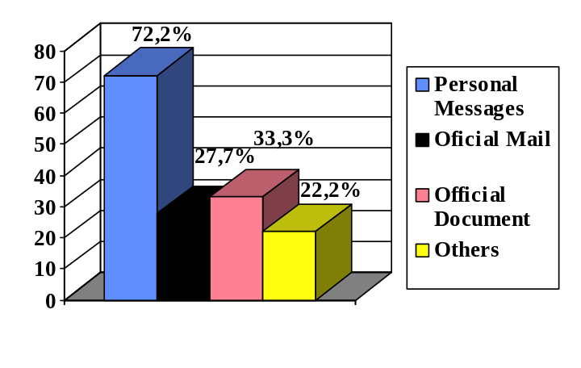
Fig. 3.4: Basic usage of e-mail by employees

Integration
All users mentioned word processors as a prime candidate for directory integration. As such, these should be the second tool to be considered for close integration with the directory (the first one being the e-mail UA). Fax servers are also mentioned, as are office automation packages like Team Office and All-In-One.

Networking
When asked about the protocols used, the most common answer is “Ethernet with TCP/IP”. In relation to the physical and data link layers (referred to as “hardware”), Ethernet is the common answer with just one case using dial-up to build TCP/IP connections.
The network protocols used are typically TCP/IP, LAN Manager or Novell (IPX). Exceptions are one organization using Decnet, and several others using protocols to be superseded, e.g. RCL, or marginally, e.g. NETBEUI.
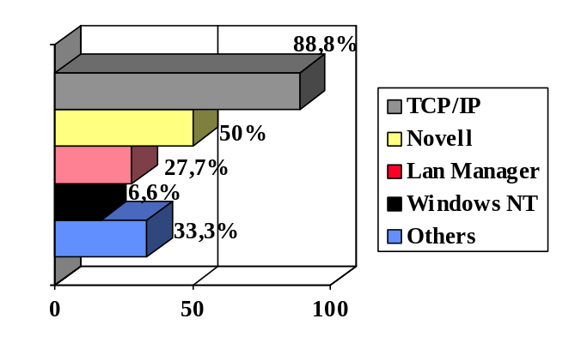
Fig. 3.5: Popular protocols used in the organizations
Answers to the question “Are all sites connected?” differed considerably. Some organizations have just one site whereas others have full connectivity between sites by means of a router and leased lines or similar. Many others have partial connectivity for e-mail purposes only. In this case 68% of the organizations have all sites connected.
The typical connection map is X.25 for X.400 mail and, increasingly, IP lines (either leased or dial-up) to connect to an Internet service providing connectivity to the SMTP community.
Before the explosion of Internet, X.25 was more commonly used for building e-mail connections. Now many administrations are using Internet connections to launch WWW servers, to collect information from the Internet and to access the SMTP community directly. It is hard to say categorically whether IP connectivity will replace X.25 lines, but many organizations admit to having plans to transfer to the Internet by either leased lines or ISDN.
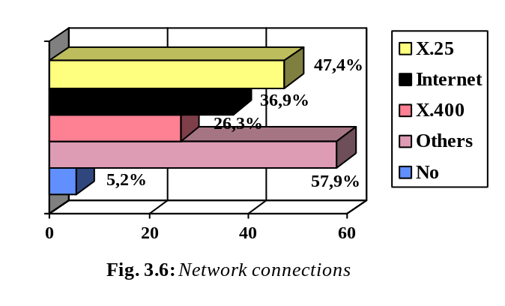
In Spain, where many of the end-users were located, the interviewed organization MAP co-ordinates e-mail between public administrations. They operate the root MTA for the Spanish administrations, routing inter-ministerial mail and acting as a gateway to a Spanish ADMD (Telefónica-Mensatex) and to SMTP-Internet. To connect to the MAP, some Spanish organizations use dial-up, others use X.25.

Existing links with other entities
The group of questions “Existing Links With Other Entities (1)” proved the most difficult to answer. The question in its original form was :
“What other organizations/ administrations/ departments in the EU does this organization work with? List them sorted by size or importance of the information interchange (both electronic means and paper), indicating for each entity the different means of transmission used (courier, mail, fax, e-mail, other) and the percentage of the traffic for each”.
No organization answered this question completely and, in many cases (60%), no figure for external traffic (neither telematic or any other type) was provided.
It has always proved to be difficult to ascertain the amount of postal mail that an organization interchanges due to the mail service not usually being centralized or accounted for in any one department. Neither the amount of traffic nor its distribution by destination (local/national/European) could be reported by some organizations.
What did come out of the question was an indication of which other organizations were communicated with by the interviewed organization. All users seemed to think that having access to the directory data of other organizations (and vice versa) would be useful.
Obviously, the degree of usefulness will depend on the amount of information available, i.e. how many organizations communicated with by the user have an accessible directory database.

Categories of organization to include in the directory service
What organizations should be included within the directory service? If we take into account the organizations that the end-users work with and their answers to the question “what other organizations might find it useful to have access to your directory data?”, it is possible to ascertain the categories of organization that should be included in the directory service. The most popular organization categories were:
- National administrations (ministries and other central entities) of the same country.
- European institutions (Council, Commission).
- Regional administrations of the same country (autonomous communities or equivalent).
- Other national, regional and local administrations in Europe (ministries, regional authorities, missions, etc.).
- Local communities and their associations in the same country.
- Research centres (e.g. CSIC) and universities (included in the IRIS net, etc.).
- State owned companies (Spanish railroads, Spanish seaports, etc.).
- Private companies (power industry, etc.).
- Partners in European projects.
- Internet ISTMO.
- NATO.
- UN.
- British Government on-line activities (G7).
The current means of communication include postal mail and courier (paper and magnetic tapes), fax, e-mail and telex. The reported figures on e-mail traffic loads are not overly significant and are difficult to compare. The general feeling is that there is still too much reliance on paper documentation.

E-mail traffic load
Sometimes the e-mail traffic loading is quite asymmetric, where input and output loads vary considerably.
A good example of this was KGSt answer about fax traffic: “The proportion of incoming fax messages is probably more than 50%, while amount is less than 50% for outgoing requests. (What is not strange for an information provider: requests/orders come in by fax, the information material is sent by mail)”.
Put another way, the total communication related to each partner is not always proportional to the level of e-mail communication.
Many organizations did not report a figure for the percentage of documents exchanged by e-mail internally and externally. As mentioned previously, it is not easy to calculate the usage of postal mail and some organizations do not even have controls on the use of e-mail.
As expected, e-mail is the preferred medium for internal message interchanges. In some cases the level of usage reaches 95-100% (SEUE), but is usually somewhat lower.

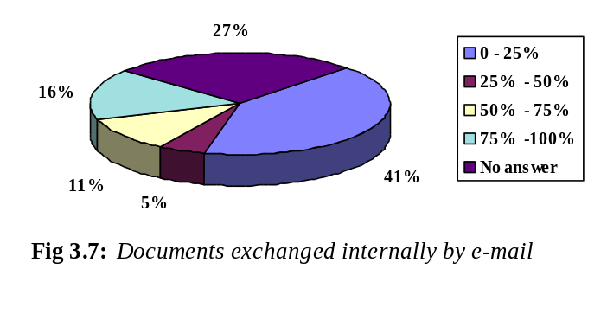
The second most popular medium has a level of usage often below 10%.
As stated previously, the general feeling is that there is still too much reliance on paper documentation and that e-mail usage needs to expand: there is only one organization (MW) where the e-mail traffic load appears to be high both internally and externally.
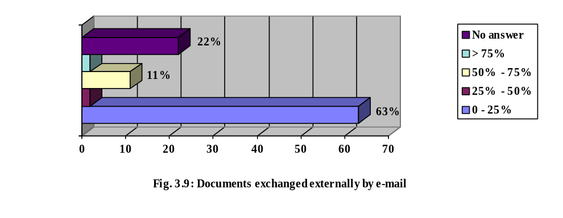
In most cases, e-mail traffic within European institutions will become more important in the future. Strong growth is expected: The European Commission will request all documents to be submitted by e-mail from next year onwards.
Another example: there is a large number of documents (ca. 12000 per year) which are distributed from the Secretariat of the European Council to various sites all over Europe. This distribution is done in cascade, currently by using various electronic media. In the future, the process is to be completely e-mail based. The European Council is currently setting up a procedure for this process and the X.500 Directory Service (together with X.400) is envisaged as infrastructure.

Directory data
The following list was indicated by end-users as being the data deemed most useful for a future directory service to provide on peer organizations:
- Personal name
- Organization name
- Post (name, roles and responsibilities)
- Organization unit and/or department
- Hierarchical relationships
- E-mail address
- Internet address of systems
- Postal address
- Telephone number(s)
- Fax number(s)
- Type of e-mail
- Other communication and document processing facilities
- Activities and services provided by the organization
- Security certificate
- Distribution lists

Existing directories

Directory types
Within each of the interviewed Spanish Administrations there was often an internal directory (telephone directory or similar) generated by any automation tool (word processor, dBase 4, etc.) and existing in a paper printed version only. In addition to this, a paper-based directory of high posts in the whole Spanish Administration (called FAC) is managed by a private company and sold to almost all administration organizations. Finally, the MAP publishes the structure of the upper Administration levels in a directory. This includes data on every institution it is connected with (ministries, autonomous communities, etc.). This directory has a search function and is distributed by e-mail.
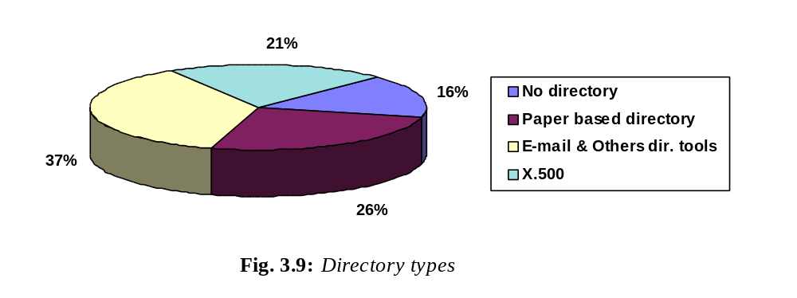
Several users have an X.500 directory service currently in use, although some of them have only partial functionality. For instance, the Isocor-X.500 directory of the MC is automatically configured with all X.400 information from the Ministry and they would like to extend it with additional data.
Probably the most developed service is located in MW. Some interesting comments about it are made in the following two paragraphs:
“The Magistrat operates 2 DSAs, predominantly used for e-mail address mapping. For each message entering the Magistrat, the external address is replaced by an internal address containing inter-organizational routing information. Therefore about 5 queries per message are started. The amount of e-mail is about 2000 messages per day. Interactive requests are much less frequent: about 200 per day”.
“The information is not managed directly in the Directory but taken from various sources. Among these are the Magistrat’s payroll, telephone directory and All-In-One user tables. The information is uploaded from these sources each week.”
Other organizations had to overcome massive obstacles to convince the office employees of an organization to use X.500. One of the objections was that data is concentrated in the Directory, which is a potential contravention of data protection laws. Another objection was the fear of losing autonomy over the data. These organizational problems will be greater if external access to internal data is allowed.
Other examples of existing directories is the miscellaneous directory service provided on the CCTA Web server which includes a directory of governmental organizations with A-Z mapping to function and organization name. For other government departments, the CCTA may be able to offer a limited set of contact data on all government organizations using the “Civil Service Yearbook” CD-ROM, which contains the necessary information. The CD-ROM is under copyright of the HMSO (the Government stationery office) and may therefore be unavailable for use by EuroView.

Opinions
Opinions on the usefulness of the service range from “quite useful” to “absolutely necessary”, for both internal and external information. Most think the available data is not good enough and should be improved. For instance, most organizations work with other organizations on which they possess only incomplete data and would like to include these organizations in a future directory. Moreover, other users consider that their existing databases do not hold all of the information required by a directory service.
They also pointed out that currently significant administrative overheads are related to address changes, which can be limited by directory access. In general, the usefulness depends on the amount of information available (i.e. how many of the organizations that the users work with have a directory entry?), the searching mechanism and other factors (e.g. the possibility general mailing using a directory lookup which does not require the typing of a complex e-mail addresses every time a message is sent, etc.).

Access method
The access method is a rather important issue. Several answers underline the requirement of providing both personal and role (functional) entries; The users will like to conduct a free search (by activity, organization, etc.), although it should also be possible to look up roles instead of people (which change too often) and distribution lists.
An issue related to the access method is the proprietary directory products (e.g. Osiware, Nettel) that only support their own tools.

Functional search
Several organizations would like such a functional search of the data such that searches can be made on the various organizational roles, with each role entry then being mapped onto the appropriate person or group of people. In the same way, the MAFF have already considered presenting a function oriented search of the data, specifically for functional role mailboxes. But they think that a comprehensive view of this nature would be difficult to organise and maintain. A business analysis will be required to ascertain the requirements of and need for such a service.
Others organizations would like the directory to implement an identification system of the information services associated with every entity. For instance, to be able to answer the question “What is the name of the Lérida Council public information system?”, giving the name of the Web server, Videotex address, etc.
In the long term, the MAP wants to create a multi-sector clearing centre for e-mail (transmission registration, generation and distribution of public and private keys, EDI, etc.).
In relation to the source of the data used in the directory, almost all DBMSs in the market are present in administrations (including Ingres, Oracle, Dbase III, Informix, Access and other sources such as text files and indexed files). As expected, the number of interfaces to the directory is large, and the task of loading user data into the directory will require some effort in finding intermediate standard formats between the database and the X.500 DIT.
Those using Oracle or Informix may well have an easier task since the tools for exporting data are well known. Those with free private formats will require specific developments for the conversion.

Service conception

Different views
Most users are interested in having different “views” of the data. This would allow an organization to present, for example, a comprehensive view of the data for internal users and a more restricted view for external consumption.
Only a few organizations seem to be uninterested in this issue. The reason given for this is that all data they would like to include in the directory is already considered “public”. In addition to this, they do not have any special legal or security requirements except the ones coming from the national data protection law.
It should be pointed out that most users are not familiar with data protection laws, and in some countries these laws are quite restrictive (France being a good example).
On the other hand, the organizational problems discussed below are seen as a greater obstacle than requirements arising from data protection regulations.
In addition to data privacy there is a secondary reason for the different views. This is the fact that some entries/attributes are technical (i.e. for system use only). Among these are the All-In-One-ID or the corporate RFC 822 address.
So the users interested in having different views are divided into those who think an internal (private) view and an external (public) one would be a good solution, and those who think that having these views would not probably fulfil data protection requirements satisfactorily and would therefore like a different set-up. Several organizations (15%) found no real difference between the public and private view other than the structure of data (white pages/functional view).
It seems more sensible to consider those private fields depending on an entry. Examples which could fit into the public/private view would be: telephone numbers and/or e-mail addresses (e.g. of directors, managers), or the department attribute of all employees. Private messaging data examples would be: number of personnel, login IDs, etc.
This problem is even more difficult to solve when an organization is dealing with data from other external organizations and putting it into an integrated directory service on their behalves (KGSt). It is not clear if it is desirable and/or possible for KGSt to put information about their members (attributes containing pricing information, etc.) into the directory. As stated by the KGSt, additional attributes are needed which contain pricing information and such attributes would obviously not be in the public view. They would probably not be available in an internal view either, however, as there is no information which the local community itself could or should provide. The “external view from the KGSt perspective” of the local community entry contains more information than the internal view. This might be an interesting User Agent feature, to provide a view on a directory entry which is an extension of the entry as it is in the directory, with the additional attributes having been taken from some local database.

Security requirements
Issues on security requirements raised by the users are as follows:
- If the directory server is managed by a third entity (e.g. EuroView), the users may have to send their sensitive data to it, if at all.
- The requirement that only authorised people may modify any data provided in the directory should be enforced using identification by password.
- In some countries (including Spain) the law requires the registration of all databases with personal data.
- Several users have some special security requirements. For example DGTel (data about military frequency assignments, etc.).
- Does the provider of directory information give any guarantee for the integrity of the data or is it possible to store directory entries without guarantee? What might be the legal implications of such a guarantee?

Access to the directory service
The question “How many people in the organization would want access to the directory service?” produced the most common answer “Every (or nearly every) potential user of e-mail”.
An interesting answer came from KGSt: “Depends on the usefulness of the service in terms of quantity and quality of data, the quality of the user interface and on the cost of the service”.
The answer “X entries corresponding to X potential users of e-mail would be wanted” demonstrates a limited view of the directory, probably arising from the fact that the users were not too familiar with this service. Those with more experience in directories would prefer the directory to serve e-mail, telephone, post, and telematic access to the organization.
Although some organizations did not answer the question about computing equipment, it has been inferred that everybody with access to the directory service will have a desktop PC.

Response time and availability
The response time requirement expressed by the users ranged from less than 10 seconds to up to 60 seconds:
≤ 10 seconds (21% of the organizations)
10-15 seconds (10.5% of the organizations)
≤ 30 seconds (21% of the organizations)
30-60 seconds (21% of the organizations)
few seconds (10,5% of the organizations)
No answer (16% of the organizations)
These are maximum times corresponding to remote access for a simple consultation.
The responses given concerning the requirements for service availability were:
Total (53% of the organizations)
Total in Working Hours (26% of the organizations)
98% (11% of the organizations)
No answer (10% of the organizations)

Integration with other tools
It is assumed that e-mail software shall be integrated with the directory service. Other software considered for integration would be office applications (word processors, diary managers, etc.), mailing applications, safety software, telephony applications (click and dial), Web servers, business applications (form entry, EDI, business transactions, etc.) and various proprietary user applications.
An example question posed (by MAS) was: “How would information transfer from the EuroView user agent to OpenMail be done?”. Integration with other tools is a basic requirement: “A directory service without potential for such integration is regarded as less useful.”
It was also noted that integration should not be limited to the client side only. The source databases (Ingres, Oracle etc.) might provide X.500 interfaces to at least part of the data they are storing.

Data maintenance procedure
- Most organizations would prefer to run a local directory service, probably with help from EuroView. So from the user persepective the directory will ideally be distributed with each user organization holding it’s own data (this could be especially suitable because of the variability of the data) and having complete control of their server. As it happens, some users are already running their own X.500 DSA(s).
- 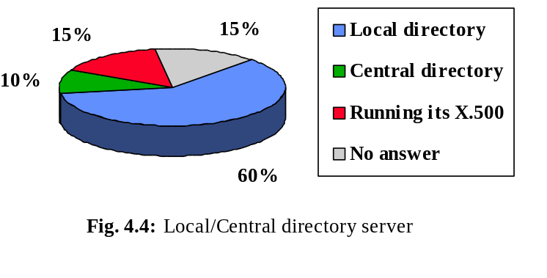
Other organizations (20%) would like to have more information about this issue before making the decision to become pilot users. The implementation of a directory service (or perhaps a directory service based on X.500 technology!) is thus still an open question for them. Only the CINDOC and the CCTA would prefer to send their data to a central EuroView directory service. In the first case this is due to the CINDOC not being confident in their ability to maintain the directory; in the second case the CCTA said that they would rather not expend any effort on converting the data and running their own DSA. Neither the CINDOC nor CCTA answered the question about the way they prefer to periodically update the information:
- Generate a file in an specific format with the changes and send it to the directory manager.
- Connect remotely to the directory and directly update the information.
Other concerns relate to regular data loading and ensuring that data updates are performed correctly. Most users would prefer a local server in order to losing autonomy over data. To this end users said that they would welcome any support (from EuroView) on process documentation, equipment maintenance and manager training and support. Training potential users to use e-mail and related applications would also be useful.

Miscellaneous
Finally, other concerns addressed by the users were:
The administrative domains are not well-organised at this time. For example, it is not yet clear who is the official naming authority represented by the country-level entries. This is true for most European countries, and appropriate actions by EuroView were requested.
Integration with existing X.400 services.
The quality of the service, bearing in mind that it is decentralized and dependent on the ability of each organization to keep its data up to date and on the reliability of links to each DSA involved in a query.
In relation to the EuroView pilot service and its starting date; and the concertation with other European activities of the various DGs (namely DG III and DG XIII) and the Secretariat of the European Council.
In relation to this last point, the MAS pointed out the fact that different proprietary systems are used to access the different telematic services of the European Commission (e.g. project Eurodesk uses a product called First Class, while the project Handynet uses its own product). They stressed that this does not favour the use of open protocols.

User requirements reference
Having presented the questionnaire and an analysis of the answers, this section summarizes the conclusions drawn from the survey. The user requirements are inferred from the answers given.
It should be noted that these requirements are not only applicable for the pilot service, but for a generic electronic directory to be used by the public administration.

Directory Data

Typical content of the directory
Whilst all agreed that personal information should be included in the Directory, it was not unanimously agreed that this information should be publicly visible.
Various objections had been raised relating to privacy of personal data and to an organization’s interest in keeping some information on their employees out of the public domain (these concerns are described in next section - Different Views).
The minimum total number of entries would be equal to the number of e-mail users (or potential users) within the organization. It would also be quite useful to include other entries corresponding to other people or organization units without direct access to the e-mail service.
Organizations that should be part of the directory service
Req. 1: All parts of national administrations (central or federal, regional and local administrations) in Europe.
Req. 2: European institutions (Council and Commission specifically). This shall include the autonomous bodies of the Ministries, etc.
Req. 3: Research centres, universities and organizations taking part in European projects (research or otherwise).
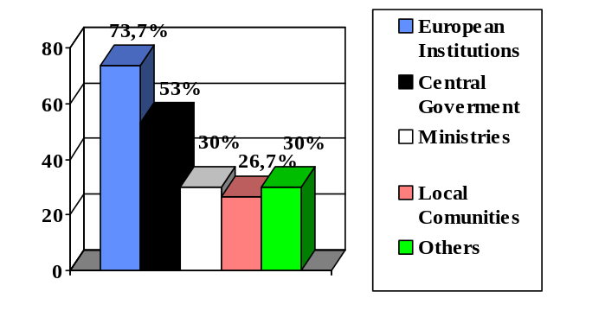
Fig 4.1: Organizations to be included
Other international organizations (UN, NATO, etc.) can be included as well as state owned and private companies (particularly public services such as energy, water and transport, etc.).
These requirements, although expressed by the interviewed organizations, are out of the scope of the pilot service. The objective of this project is to promote the use of X.500 directories, including the creation of an initial user group. This will provide the first steps along the road to achieving a critical mass of service providers and users in the future. It is unfeasible to achieve this number of users under this project, despite this it has to be noted here as a requirement for a full service.
Req. 4: An entry shall typically comprise of the following data:
- Personal name
- Organization name
- E-mail address
- Postal address
- Telephone number(s)
- Fax number(s)
- Post (name, roles and responsibilities)
- Organizational unit and/or department name
- Hierarchical relationship
- Activity and services of the organization
- Type of e-mail
- Other communication and documentation facilities and distribution lists
- 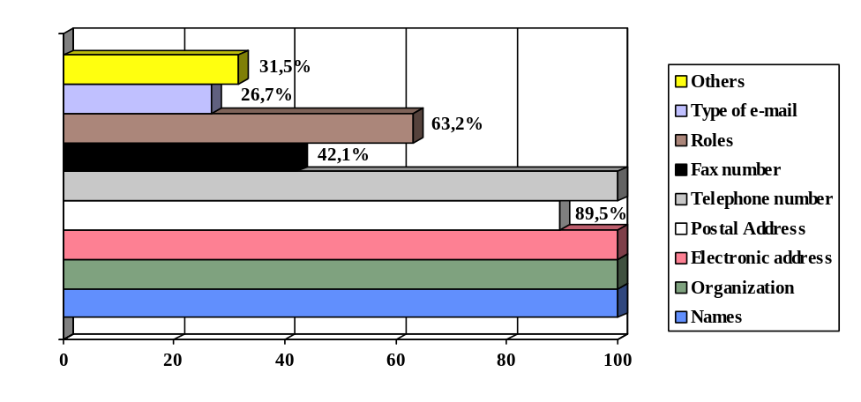 Fig. 4.2: Data of other organization

As shown in the diagram, names (organizational and personal), electronic address and telephone data was requested by 100% of the interviewed organizations. Other fields were suggested depending on the nature of the organization.

Different views
Req. 5: There should be strong possibilities different views of an organization’s directory data.
There are several reasons for this:
- Data privacy (addressed by data protection laws)
- Technical entries/attributes (for system use only: mail routers and others)
- The organization’s wish to limit access to some employee information
The provision of two (or more) different views addresses many of the requirements listed above. The internal view will typically include personal information to be consulted by organizational staff, whereas the public view will include functional information about the organization and how to locate it’s official contacts.
The provision of internal and external views does not address the issue of data protection satisfactorily in all cases. For this reason it may be advisable to provide more than one homogeneous internal view - a normal internal view (accessible by everybody within the organization), a private or confidential internal view (with restricted access only) and a technical internal view (system access only). In addition to this, parts of the internal view may be made accessible externally to selected individuals.
In practice it is often very difficult to safely identify the user querying the directory (i.e. avoiding possible attempts at impersonation). Additionally, security policy is difficult to encode and maintain with the current technology. As a result it may not be possible to satisfy the requirement for many views.
The best solution would be to make each field of each entry individually configurable. This would then enable the creation of different views according to the needs of each organization, providing a solution to related organizational problems.
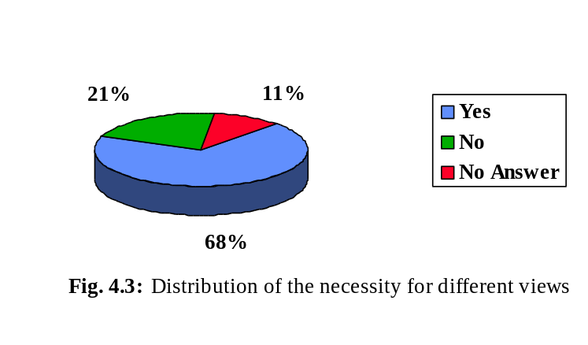

Another aspect of this subject is the set of identification data to show in the different views. At least two different profiles are identified, a staff view (personal entries) and an organizational view (functional role entries).
It would be desirable to have a functional view of the data where different organizational units and their functional roles might appear, although a comprehensive view of this nature will be difficult to organise and maintain.
As a final conclusion on this point, the entries and views suggested here provide a good framework for the generic organization. The specific needs of some organizations, however, would require further business analysis for a detailed DIT (Directory Information Tree) design.

Data maintenance
The only options available in this area are:
- To maintain a local directory in a computer belonging to the organization.
- To send the directory data to an external service provider (similar to the service maintained centrally by EuroView).
Most users will prefer a local directory server in order to maintain control over data updating and user access.
This complies with the underlying X.500 philosophy of data distribution, with every organization taking responsibility for it’s own directory (data accuracy, performance, etc.).
But to run a directory implies some investment in computing equipment, software licenses, communication lines and above all maintenance effort. Not all organizations have the required resources for such an investment.
The choice of which of the two options to select will therefore be motivated by the organization’s commitment to the service and the amount of resource available. Of course in most cases the resource allocated to any project is proportional to the level of importance associated with the goals of that project!
The issue of directory updating results in two possible options. Both options may be equally suitable for the user and both should be feasible.
Req. 6: At least two methods of data maintenance should be made available to every organization in the directory:
- A file could be generated in a specific format containing the changes to be made, to be sent to the directory manager.
- A remote connection could be formed, thus allowing the directory to be updated directly.

Connectivity
In the pilot scenario there will be some servers owned and managed by participating organizations and three central servers managed by EuroView, one in each of the three partner countries (DE, UK and ES).
For those private servers, the connection requirements are focused on internal access to the server, although in many cases the main usage of the directory comes from the external organizations querying local entries.
Req. 7: The basic connection method is TCP/IP.
All servers should have IP connectivity with the national server at a minimum, either full Internet (if the organization already has this facility) or leased or dial-up lines (using SLIP or PPP to implement the IP connection to the server). The latter solution has an associated financial and operational penalty since the local server is only accessible when the (possibly expensive) link to the national server is working.
Req. 8: The three national servers should implement connections to international X.25 and the Internet.
This will allow them to act as gateways, interconnecting servers located in different networks and using different protocols.
The use of closed networks (private X.25 networks in particular) is a problem for the pilot service. The scenario where a EuroView server is not able to connect to a certain user has to be taken into account when designing the service, although it is expected that any organization wishing to join the pilot will accept the need for IP or public X.25.
It must be pointed out that Internet connection results in some security problems since sensitive data will sometimes be stored in the servers database.
Req. 9 : Access to the Internet shall be protected against security attacks.
Firewall services will have to be studied carefully and deployed to achieve an acceptable degree of security. This may be more difficult for private servers, and each case will have to be studied on its own merits.
Req.10:Aaccess to the directory through a WWW service shall be provided.
The explosion of WWW servers and clients indicates a strong need for a WWW gateway to the X.500. This service would be located in each of the three national servers, and would consult local data and other servers through X.500, and offer the results as HTML pages. Although the functionality cannot match that of a full X.500 service this is a good way to promote the directory service and make it widely accessible.
Req. 11: Replication of the data in the directories shall be used to reduce the traffic at national and European level.
The EuroView servers shall replicate sufficient information, in particular the root context and the particular national contexts using the X.500 1993 replication facilities, to avoid excessive traffic for trans-national queries.
Req. 12: Directory links with other directory services of the European Commission, other institutions of the European Community and with NameFlow-Paradise, shall be implemented.
Analysing the answers to the questions on “Existing links with other entities”, it is clear that the range of directory information made available to an organization cannot be limited to other users of EuroView. Similarly, directory information concerning an organization cannot be made available solely to other users of EuroView.

Directory usage

Facilities
Req. 13: The Directory User Agent shall be made available as a tool to run on the desktop PC.
The User Agent is the most visible part of the service and is a critical factor in providing user satisfaction.
In the case of EuroView, however, the functionality of the User Agent will be constrained due to conformance to the X.500 standard which defines the querying services available to the user. As expected, all services shall be supported by the User Agent.
Free searches by activity, organization, etc. will therefore be allowable operations. It will also be possible to search on an organizational role rather than a personal id (which changes too often), with each role entry being mapped onto the appropriate person or group of people. Another useful facility would be an identification system of the information services associated with every organization, giving the name of the Web server, Videotext address, etc.
The design of the user interface must be ergonomic and adapted to the use that a typical user would put it to: grouping the more frequent commands, showing everything in a coherent representation, etc.
The User Agent for the pilot service will be developed from the existing PC-Pages package. This product has been demonstrated to various future users, and they have expressed their satisfaction with its functionality. On the issue of user interfaces, therefore, all user requirements have been dealt with from the onset.

Integration
Office automation tools
Req. 14: The User Agent shall be integrated with e-mail and word processing tools as a minimum.
“A directory service without such an integration is regarded as less useful”. That e-mail software should be integrated with the directory service seems to be a unanimous opinion. Other potential software suitable for integration would be office applications (word processors, diary managers, etc.), mailing applications, safety software, telephony applications (click and dial), Web service and business applications (form entry, EDI, business transactions, etc.) .
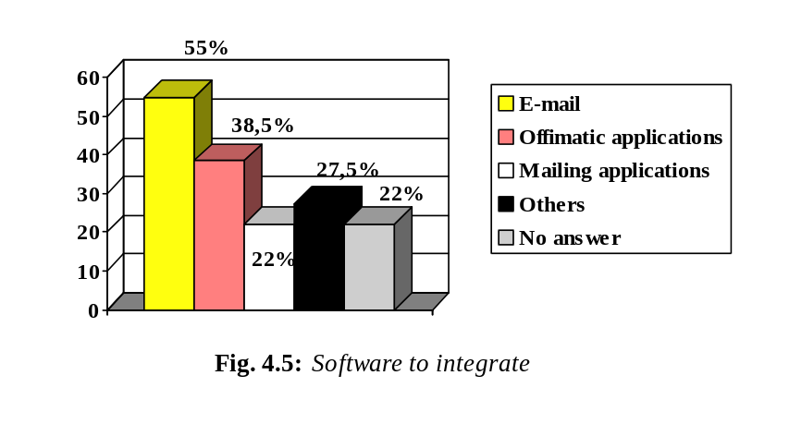
Existing databases
It was also noted that integration should not be limited to the client side only. The source data bases (Ingres, Oracle etc.) might provide the means of presenting data in a format more suitable for the loading of the directories.

Availability and response time
The times presented were maximum times corresponding to a remote access for a simple consultation of the directory. In reality of course, there would be complex consultations which would take more time.
Req. 10: Due to technical reasons the response time shall be less than 30 seconds
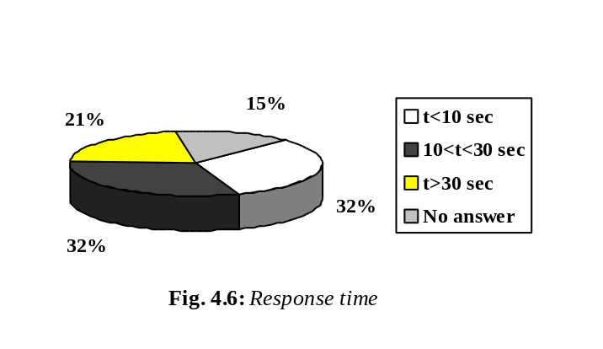

Req. 11: The service should be made available for 98% of the time, ensuring it is available during all working hours.
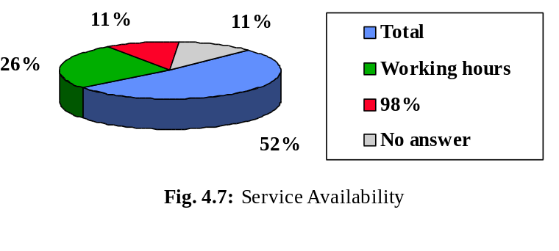

Legal and security requirements
The legal and security requirements are related to access, usage, maintenance and correctness of data. These aspects have been addressed in the sections above (different views and centralised or local directory servers).
A general security requirement could be identification by password. It is essential to ensure that only authorised personnel may access non-public data (i.e. internal or system data views).
Organizations using the external directory service providers could experience security problems, as this would involve transferring sensitive data to an external organization, perhaps a private company.
The data maintenance procedures must guarantee that only authorised personnel are able to modify directory data (either the owner of the data or the directory manager).

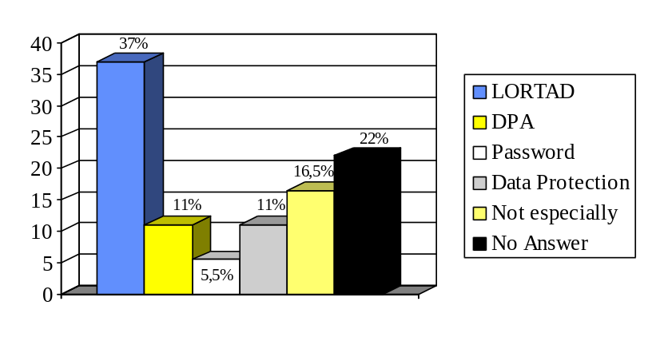
Fig. 4.7: Legal and security requirements

It may be appropriate for the provider of directory information to give a guarantee on the correctness of data. If this were the case, many legal implications may result. This issue, together with other issues related to legal and security requirements, will be addressed in another phase of the project (the study of national and European data protection laws).
Some surveyed organizations had specific security requirements due to the presence of important information involving national security, etc. These problems cannot be addressed in this set of general requirements but must be considered and reolved closer to the time of service implementation.
The question of top level naming has not yet been solved satisfactorily in European countries. It is not clear who the official naming authorities representing country-level entries are. This is the case for most European countries, and appropriate actions have been requested from EuroView.

Specific requirements stressed in individual interviews.
MAP: Would like to use the directory for key distribution support, as part of a future clearing centre for telematic services: registered e-mail, EDI, Certification Authority, key distribution, etc.
DGTel: Said one of the problems with e-mail is signature recognition in official documents.
MAFF: Would like to use X.500 as the central repository of all communications information, e.g. telephones, video conferencing, etc..

Appendix A. Organization and People
This appendix presents a summary of organizations that have been interviewed. Each organization is represented by a code:
AA | Auswärtiges Amt (German Foreign Office), Fischer (Co-ordinator of the Telecommunications Projects of the German Foreign Office)
CAIB | Comunidad Autónoma de las Islas Baleares (Regional Administration of Belear Islands, Spain), Fermín Calvo Torre (Manager of the Balear Institute of Telematic Innovation, IBIT)
CAPV | Comunidad Autónoma del País Vasco (Regional Administration of Pais Vasco, Spain), Luis Latxiondo Izaguirre (Member of the Sociedad Informática del País Vasco)
CARM | Comunidad Autónoma de la Región de Murcia (Regional Administration of Murcia, Spain), Juan García Botia (Responsible for Telecommunications)
CAV | Comunidad Autónoma Valenciana (Regional Administration of Valencia, Spain) Enrique Valls Muñoz (Responsible for I.S. and Communications);
CCTA | Central Computer and Telecommunications Agency (United Kingdom), John Groom (Responsible for Directories)
CINDOC | Centro de Información y Documentación Científica del CSIC (Information and Scientific Documentation Centre of the Scientific Research Council), Spain, Mª Teresa Fernández (Responsible for Computing Services), Rosa de la Viesca (General Manager)
DGTel | Dirección General de Telecomunicaciones (Spanish Office of Telecommunications), Pedro L. Alonso Manjón (Responsible for the General Manager’s Supporting Area)
KGST | Kommunale Gemeinschaftsstelle (Association of local authorities, Germany), Kassner, Asselborn (Responsible for the data processing infraestructure), Raschke (Administrator of the member database)
MAE | Ministerio de Asuntos Exteriores (Spanish Foreign Office), Miguel Sedeño (Responsible for E-mail Service)
MAFF | Ministry of Agriculture, Fisheries and Food (United Kingdom), Shaun Soper (Responsible for Information Technology Infraestructure)
MAP | Ministerio de Administraciones Públicas (Spanish Ministry of Public Administrations), Pedro Sandoval (Technical Adviser)
MAPA | Ministerio de Agricultura, Pesca y Alimentación (Spanish Ministry of Agriculture, Fisheries and Food), Rodolfo Contreras (Second Manager of Computing Systems)
MAS | Ministerio de Asuntos Sociales (Spanish Ministry of Social Affairs), Joseba García Celada (Responsible for the Area of Infrastructures and Systems)
MC | Ministerio de Cultura (Spanish Ministry of Culture), Pedro del Río (Responsible for Computing Services), Teodoro Martínez
MEH | Ministerio de Economía y Hacienda (Spanish Ministry of Economy and Finance), Miguel Azorín-Albiñana López (Technical Adviser)
MOP | Ministerio de Obras Públicas, Transporte y Medio Ambiente (Spanish Ministry of Public Works, Transport and Environment), David Lleras (Technical responsible for the subdictorate for technology and S.I.)
MW | Magistrat Wien (Wien Council, Austria), Kurt Starnberger, Alexander Scheer (Office Product Integration), H. Pfläging (Mail Server and Network Infrastructure), Michael Gsandtner (Directory Service)
SEUE | Secretaría de Estado para la Unión Europea (Spanish Secretary for European Union, Foreign Office), Santiago Rodríguez (Computing System Technician), Leopoldo Simó (Responsible for Computing Sciences Area)

Appendix B. Presentation of the Project

The presentation given to organizations prior to interview is outlined here:
What is EuroView?
EuroView will bring directory services to the varied world of European administration. Benefits already enjoyed by a growing number of research institutes and universities will be made accessible to government officials, custom officers, agriculture ministries, and all the myriad intercommunicating parts of modern European administration.
What is X.500?
EuroView will build on the internationally standardised Directory (ISO 9594/X.500). The Directory provides an ideal model for storing corporate resource information because of its design for open secure and scaleable distributed information sharing across the organization and between partners. Information stored in the Directory can refer to arbitrate objects of the real world, for example organizations, employees, machines, facilities, or application programs. The information may include postal address, communication addresses and other resource information for different communication media like telephone, FAX, e-mail or EDI, but also other information, which is not particular related to communication: roles of people, for example, or even multimedia information like pictures and speech.
The Directory is a distributed system in two aspects: administration and technique, which allows the participating organizations to have local control over the information that they make available, while at the same time presenting a global, unique view on this information to the users.
What will happen next?
Starting with a survey of the particular needs and concerns of European Administrations, EuroView will express these requirements in terms of the International Standard ISO 9594/X.500. Data from sample user communities will be loaded, user interfaces built or adapted, and demonstrations arranged. The organizational, social, and legal implications of administrative directory systems will be investigated, and recommendations made for appropriate action.
About the partners
EuroView is a Project in the Telematics Applications Program of the European Commission. Co-ordination Contractor is Dr. Materna GmbH, Germany, further contractors are Brunel University Computer Centre, UK, and Sema Group, Spain.
Where to get further information?
For further information about EuroView please contact:
Karl H. Bonacker
Dr. Materna GmbH
Voßkuhle 37
D-44141 Dortmund
Phone: +49 231 5599-187
Fax: +49 231 5599-100
X.400: G=Karl; S=Bonacker; P=MATERNA; A=UMI-DE; C=DE;
Internet: Karl.Bonacker@materna.de

Appendix C. Questionnaire
This appendix presents the questionnaire used throughout the survey:

7.1 Identification of user organization
7.1.1 Name of the organization
7.1.2 Address
7.1.3 Telephone and fax no
7.1.4 Contact person
7.1.5 Sector inside the administration
7.1.6 Activity
7.1.7 Number of employees
7.1.8 Number of sites
7.1.9 Organization scope (local, regional, national, international).
7.1.10 Hierarchical location inside the administration.

7.2 Technological environment
Office automation:
7.2.1 Continuous use of office automation tools
Personal Computers (yes / no ) ;
Word processor ( yes / no) ;
Spreadsheets (yes / no ).
7.2.2 Do you use specific formats and/or templates for these tools ?
What type?
Electronic mail:
7.2.3 Product(s) used inside the organization
7.2.4 Configuration (MTA’s, User Agent’s, etc.)
7.2.5 Number of users (indicate % of total employees)
7.2.6 Profile of usage (personal messages, free text or official forms )
7.2.7 Is there any integration with other tools (word processor, etc.) ?

Networking:
7.2.8 Network hardware used
Ethernet / Token-Ring / Dial-up / other
7.2.9 Protocol used
TCP/IP / Novell / Lan Manager / other
7.2.10 Are all sites connected in some common way so that a single directory server could service all sites?
7.2.11 Network connections available to the outside world
None / Internet-leased line / Internet dial-up / public X.25 / other
7.2.12 In case there is a network connection (previous question), what is it used to connect to?
7.2.13 What changes are expected in the next few years?

7.3 Existing links with other entities & existing directories
7.3.1 What other organizations/administrations/departments in the EU does this organization work with?
List, sorted by traffic load or importance, indicating for each entity the different means of transmission used (courier, mail, fax, e-mail, other) and its percentage of the total traffic.
7.3.2 Indicate which part of the documents exchanged, either internally or with other organizations, are sent or received by e-mail
7.3.3 Would having access to their directory data be useful to us , and vice versa ?.
7.3.4 What part of the identification data would be needed?
Name, Organization, Position, Electronic address, Postal address, Telephone number, Type of e-mail, Others…
Existing directories:
7.3.5 Describe briefly any existing directory you use (Organization covered by the directory & number of entries, etc.)
7.3.6 Information contained in a typical entry
7.3.7 Type of database and means of access:
7.3.8 How useful do they find it?

7.4 Service conception
7.4.1 Would they want to present several views of the data? (perhaps an internal view and a public view?)
7.4.2 Try to distinguish which fields would appear in the public and private view.
7.4.3 How many internal entries might be wanted, and how many public entries?:
7.4.4 What legal and security requirements would there be for the public data? What for the internal data?:
7.4.5 How many people in the organization would want access to the directory service? What computing equipment do these people have access to now? What changes are expected in the next few years?
7.4.6 What other software should be integrated with the directory service?
(this might be e-mail software, but it could also be office applications like word processors, diary managers, and spreadsheets)
7.4.7 Are there existing databases holding information required by a directory service?
7.4.8 Would the organization want to run a local directory server (probably with help from Euroview) or would it prefer to send some data to a central Euroview directory service?
7.4.9 Is there any concern you feel about the service in terms of commitment for start up and maintenance, access security, or any other issue?
7.4.10 Do you have strong requirements for the response time and availability of the service? What would be the acceptable limits for these two factors?
7.4.11 What is your general opinion about the utility of the service? Do you have any suggestions to make it more useful than it has been described in this interview?

Appendix D. Review of answers to the questionnaire.
This appendix presents a summary of all answers received from the survey.
The answers are given together with their respective organization. The first table can be used to map each organization to its corresponding code.

List of Interviewed Organizations

CODE | ORGANIZATION
AA | Auswärtiges Amt (DE)
CAIB | Comunidad Autónoma de las Islas Baleares (Balearic Regional Government)
CAPV | Comunidad Autónoma del País Vasco (Regional Government, ES)
CARM | Comunidad Autónoma de la Región de Murcia (Murcia Regional Government, ES)
CAV | Comunidad Autónoma de Valencia (Regional Government, ES)
CCTA | Central Computer and Telecommunications Agency (UK)
CINDOC | Centro de Información y Documentación (ES)
DGTel | Dirección General de Telecomunicaciones (Secretariat for Telecommunications, ES)
KGSt | Kommunale Gemeinschaftsstelle (DE)
MAE | Ministerio de Asuntos Exteriores (Ministry of Foreign Affairs, ES)
MAFF | Ministry of Agriculture, Fisheries and Food UK)
MAP | Ministerio de Administraciones Públicas (Ministry of Public Administrations, ES)
MAPA | Ministerio de Agricultura, Pesca y Alimentación (Ministry of Agriculture, Fish and Food, ES)
MAS | Ministerio de Asuntos Sociales (Ministry of Social Affairs, ES)
MC | Ministerio de Cultura (ES)
MEH | Ministerio de Economía y Hacienda (Ministry of Finances, ES)
MOP | Ministerio de Obras Públicas, Transporte y Medio Ambiente (Ministry of Public Works, Transport and Environment , ES )
MW | Magistrat Wien (City Government, AU)
SEUE | Secretaría de Estado para la Unión Europea (Secretariat for EU, ES)

Identification data
Questions answered:
“Number of employees?”, “Users of e-mail/potential users?”, “Number of sites/buildings?”, “Organization scope.?”
 | EMPLOYEES | USERS/P. USERS | SITES/BUILDINGS | SCOPE
AA | 8,000 | 2,500/- | 250 | international
CAIB | 2,000 | - | >15 | regional
CAPV | - | 1,200/3,000 | 35 | regional
CARM | 6,000 | 1,000/2,500 | 24 | regional
CAV | 20,000 | 500/10,500 | 200 | regional
CCTA | 200 | 200/200 | 2 | national
CINDOC | 130-150 | 60/80 | 2 | national
DGTel | 850 | 300/800 | 40 + 52 | national
KGSt | 37 +15 (KGSt Consult) | 37/37 | 2 | national
MAE | 2,000 | 130/200-250 | 15 + 160 | international
MAFF | 11,000 | near11,000/11,000 | 197 | national
MAP | 2,000 | 500/1,500 | 7 + 52 | national
MAPA | 7,000 | 100/3,000 | 12 + 52 | national
MAS | 2,500 | 300/1,000 | 15 | national
MC | 6,000 | 100/250 | 10 + 30 | national
MEH | 15,000 | 6,000/7,500 | 675 | national
MOP | 4,000 | 250/800 | 10 | national
MW | 80,000 | 13,000/13,000 | 150 | local
SEUE | 150 | 100/100 | 2 | national

Office automation tools.
Questions asked:
“Office automation tools?”, “Specific formats and/or templates?”
 | PC/WP/SS | FORMATS/TEMPLATES
AA | yes/yes/less often | formats
CAIB | yes/yes/yes | formats
CAPV | yes/yes/yes | formats
CARM | yes/yes/yes | formats
CAV | yes/yes/yes | NO
CCTA | yes/yes/yes | formats/templates not widely
CINDOC | yes/yes/yes | formats
DGTel | yes/yes/yes | formats
KGSt | yes/yes/less often | RARELY
MAE | yes/yes/yes | formats
MAFF | yes/yes/yes | templates
MAP | yes/yes/yes | formats/templates
MAPA | yes/yes/yes | NO
MAS | yes/yes/yes | templates, headlines
MC | yes/yes/yes | NO
MEH | yes/yes/yes | formats
MOP | yes/yes/yes | headlines
MW | yes/yes/less often | NO
SEUE | yes/yes/yes | formats

Electronic mail
Questions asked:
“Product(s) used?”, “Configuration?”, “Profile of usage?”, “Integration with other tools?”

 |  | PRODUCT(S) | CONFIGURATION | USAGE |  | INTEGRA-TION
AA | MSMailX.400 (Osilink); Retix |  | 39 MTAs (MSMail); 6 MTAs (Osilink);  1 MTA (Retix) |  | Personal messages²; official mail; electronic distribution of official documents |  | MSMail/MSWord; Fax; Infofunk
CAIB | X.400 (Nettel);  Netscape;  Eudora |  | 1 MTA |  | Personal messages² and formatted documents |  | Yes
CAPV | cc:mail |  | - |  | Internal messages and documents |  | By MAPI of cc:mail
CARM | X.400 (Isopro by Isocor) |  | 6 MTAs (X.400, Isoplex by Osocor);  1,000 Mailboxes; UAs (Windows);  5 DSAs (Isoplex by Isocor) |  | Personal messages²; official communications (not administrative documents) |  | Word processors; Fax;  Gateway from Unix (SMTP) to e-mail (and vice versa)
CAV | X.400 (Osiware) with Internet gateway;  Internet e-mail compatible with POP3,  MIME |  | 10 MTAs (X.400, Osiware);RUAs (Alprange, Maxware) |  | Personal messages² |  | MSWord;  Excel;  Team Office
CCTA | Route400; Eudora |  | 2 MTAs |  | Informal messages |  | Simple attachment
CINDOC | Freeware products (POP, EAN, PINE, Pegasus, SendMail);  Eudora |  | - |  | Personal messages; official mail |  | Word processors and other offimatic tools and computing applications of their own
DGTel | OpenMail |  | 1MTA (HP),  UAs (Windows) |  | Personal messages² (free text);  official mail |  | WordPerfect
KGSt | DX-Mail (Dr. Materna) |  | 1 MTA |  | Personal messages² |  | Not yet satisfying
MAE | Vista-Mail  (to extinct);  X.400  (OSIWARE-Infonet);  ISOCOR (API’s Consular Computing |  | 3 MTAs (one by system);  100 Uas (Vista-Mail);  33 RUAs (OSIWARE) |  | Reports;  Free text (little documents);  Prefixed forms |  | Vista-Mail with Vista-Office (integrated suit); Windows for UAs and RUAs; APIs with GBDR
MAFF | X.400 (OpenPath); X.500 (SSE); Enterprise Mail (Boldom James) |  | 75 MTAs and DSAs (Siemens Nixdorf RM600w/Sinix) |  | Personal messages²;  X.440 as a transaction medium among applications |  | MSWord;  Fax;  Simple Attachment
MAP | X.400 (Nettel, ICL, Isocor, Sun)PC Clients; Servers (Unix, Windows NT, Sun) |  | 5 MTAs (2Windows NT + 3 Unix);  500 UAs (PC-Nettel, ICL, etc.) |  | Personal messages²; Official mail-boxes with list of posts |  | WordPerfect
MAPA | Isocor |  | 1 MTA (SPP, Marben);  1MTA (Isocor);  UAs (PC-Isocor) |  | Mostly official work without prefixed formats |  | WordPerfect
MAS | OpenMail; MS mail;  X.400(HP) |  | 1 MTA (X.400);  1 MTA (OpenMail);  400 UAs (PC-MSmail) |  | Personal messages²; Official mail with list of post;  Always free text; |  | MSWord, Excel, Access, etc.
MC | Isocor |  | 1 MTA (DOS);  1 MTA (Unix)  UAs (Windows) |  | Free text;  No distributions lists |  | WordPerfect
MEH | Isocor;  X.400 (ICL);  Memo (Vermation) |  | - |  | Personal messages²; official mail |  | WordPerfect  MSWord  Spreadsheets
MOP | Nettel Route 400; Olivetti Ibisys |  | 5 MTAs (Pcs) with Nettel and Ibisys;  1 MTA per subdep.;  250 UAs (PCs) with SW Nettel and Olivetti |  | Personal messages²; Attached files (MSWord, Excel...) |  | Simple attachment
MW | All-in-one (Digital) |  | All-in-one ;  Mail Bus 400, SMTP-Mailer |  | Personal messages,  partly official mail,  electronic distribution of official documents |  | All-in-one is an integrating tool

Networking
Questions asked:
“Network hardware used?”, ”Protocol used?”, “All sites connected?”
 | HARDWARE | PROTOCOL | ALL SITES CONNECTED
AA | Ethernet | TCP/IP;  Windows NT | YES  (central sites in Bonn)
CAIB | Ethernet | TCP/IP | NO
CAPV | Ethernet | TCP/IP; Novell | NO
CARM | Ethernet | TCP/IP; Novell | YES
CAV | Ethernet | TCP/IP | YES
CCTA | Ethernet | TCP/IP; Novell; ISDN (video conference) | YES
CINDOC | Ethernet | TCP/IP; Novell | YES
DGTel | Ethernet | Lan Manager | YES
KGSt | Ethernet; Dial up | TCP/IP;SPX/IPX | YES
MAE | Ethernet;ARCNET | TCP/IP; NoVell (marginal);  RCL (to extinct);  NetBIOS | NO
MAFF | Ethernet | TCP/IP; Lan Manager; Windows NT  (under evaluation) | YES
MAP | Etehernet | TCP/IP; Novell | YES
MAPA | Ethernet | Novell | NO
MAS | Ethernet | TCP/IP; Lan Manager;  Lan Manager over TCP/IP | YES
MC | Ethernet,  FDDI | TCP/IP; Novell;  Lan Manager (Windows NT) | NO
MEH | Ethernet | Windows NT | NO
MOP | Ethernet | TCP/IP;Lan Manager; Netbeui | YES
MW | Ethernet | DecNet Phase 4;TCP/IP | YES
SEUE | ARCNET | TCP/IP (for e-mail); Power Lan (net protocol) | YES
Networking (cont.)
Questions asked:
“Network connections to the outside world?”, “Used to connect to?”, ”Expected Changes?“
 | NETWORK CONNECTIONS / TO CONNECT TO | CHANGES
AA | X.25; Internet (minor use); Telex; PSTN | Much larger use of X.400 on X.25;  Replacement of Telex use
CAIB | Internet leased lines; Internet dial-up | A corporate network
CAPV | None | To create a corporate e-mail service extending to X.400 and Internet
CARM | Public X.25 / ISTMO,  Agencia Estatal Tributaria,  Dirección General de Tráfico, etc. | Internet leased lines
CAV | Public X.25 / ISTMO, Legeslative Data Base;  Internet (leased lines and dial up) / The rest | Remove X.25; Internet extension to Public Administration
CCTA | Internet leased lines (WWW, e-mail, FTP, etc.) | The X.400 (internal) and Internet (external) mail systems will be unified
CINDOC | 100 Mbps FDDI ring / CSIC, IRIS Net (Internet) | Improving the ring bit rate to 150 Mbps
DGTel | X.400 on X.25 (international e-mail);  X.400 / MAP (IRIS Net, Internet) | None particularly
KGSt | Public X.25;  Internet dial-up (Tonline, from an isolated PC) | Connection to Internet; KGSt will become an information provider in the WWW; More use of the Internet than X.25 for e-mail
MAE | Public X.25 / external MTAs Internet dial-up / UN, European Institutions; Point to point lines (?) / MAP | To connect all sites by IP routers;  To unify net HW and protocols to Ethernet TCP/IP;  To unify all sites in Madrid into an only building
MAFF | Public X.25 (e-mail only);  X.400 only to Internet | Moving to EDI, Suppliers providing added services such as automated document generation, workflow and group communication SW;  WWW service for internal documents;  Help desk services also via WWW;  Will look at data warehousing
MAP | Public X.25 (e-mail) / IRIS Net (Internet)  Internet with firewall (exit to WWW, but not entrance  ISDN (Remote access to LAN)  Dial-up (e-mail) | Dedicated connections for e-mail; ISDN more important to the detriment of X.25 and PSTN
MAPA | Public X.25 /RePer, MAE, MAP,  Other Ministries (Through MAP) | Normal growth
MAS | X.400 over PSTN / MAP;  X.25, X.400 / Other Ministries;  X.400 / IRIS Net (Internet) | Direct connection with X.400.Internet world
MC | Internet-leased lines / IRIS Net (Internet)  9,600 PSTN / Data bases of the MC with external organizations;  Public X.25 / Iberpac;  Internet | None particularly
MEH | X.400 on Public X.25;  PSTN / European Institutions;  Internet dial-up / Internet servers | Offering WWW pages and “on line” public information
MOP | Internet leased lines / WWW,  gateway to SMTP world;  X.400 on X.25 / MAP | Move MTAs to Unix, possibly SCO
MW | Internet leased lines / EUNET Austria (external traffic, mail by SMTP);  Public X.25 / Radio Austria (some communication with DEC);  SNA / Osterreichisches Statistisches Zentralamt | Internet leased line 64 KB will be extended to a 2 MB link
SEUE | Public X.25 / low traffic MTAs;  Point to point lines / high traffic; PSTN/RUAs | Vegetative growth

Existing links with other entities
Questions asked:
“What other organizations in the EU does this work with (interchange information)?”, “Different means of transmission used?”, “E-mail traffic load?”

 | ORGANIZATIONS |  | TRANSMISSION MEANS | E-MAIL TRAFFIC LOAD
AA | European Institutions; NATO; UN; Other German Ministries; Other European Foreign Offices and Missions all over the world | E-mail; Fax |  | 1,40 Million messages/ year (including notifications, multiple counting of relayed messages, etc.);Net amount = 0.14 Million
CAIB | MAP;  European Commission; Partners in European Projects |  | E-mail, Fax | -
CAPV | - |  | - | -
CARM | INTERNET-ISTMO; Ministries;  European Institutions |  | Postal mail; E-mail | 61 MB/ month (?)
CAV | Ministries; European Institutions |  | Courier; Postal mail; Fax | -
CCTA | Government On-Line Activities (G7), encompasses all goverments; Client Administrations (mainly UK and a few in other countries) | - |  | -
CINDOC | CSIC; Universities; Private Companies; European Institutions |  | 90% Postal Mail | 16,000 messages/ month
DGTel | - |  | - | -
KGSt | Local Communities (members); Associations of Local Communities Power industry Companies | Fax; E-mail |  | -
MAE | SEUE; Foreign Office and Home Offices in EU; European Institutions; MAP; Customs and MEH | E-mail; Telex;Point to point lines; Magnetic tapes |  | -
MAFF | Administrations within the agriculture and food sector (Projects as ANIMAL, IDES or FIDES); Other organizations within the agricultural sector covered by DG6 | - |  | -
MAP | IRIS Net;Other Ministries  Autonom. Communities; European Institutions |  | Paper; E-mail | 4,500 single messages (80 MB)/ month. Each message can be distributed to several destinations
MAPA | SEUE (Through RePer); European Institutions (Through RePer); Autonom. Communities |  | - | 700 messages/ month
MAS | Autonom. Communities; Other Ministries ;European Institutions |  | Paper; Tapes; E-mail | -
MC | - |  | - | -
MEH | Local Councils; Autonom. Communities;  Other Ministries;  State owned Companies;  European Institutions |  | - | -
MOP | Spanish Railroads; Spanish Sea ports;  Other European Administrations; Autonom. Communities; RePer |  | - | -
MW | Federal Administrations; European Commission; Other European Regional and Local Administrations; International Health Area | E-mail, Fax, EDI |  | -
SEUE | RePer; Ministries; European Commission |  | - | OUT: 9,000 messages (120 MB)/ month IN: 5,000 messages (55 MB)/ month
Existing links with other entities (cont.)
Questions asked:
“Percentage of document exchanged internally and externally by e-mail?”, “To which other organizations would you consider directory access useful?”, “Required identification data?”

 | Internally/Externally | Other organizations to include | Data of other organizations
AA | -/ - | European Institutions; NATO; UN;  Ministries;  Other European foreign offices and missions over the world | Names/ Organization/ Organization unit and department/ Electronic address/ Postal address/ Telephone number/ Fax number/ Roles/ Distribution lists/ Communication and document processing facilities
CAIB | 60-70%/ 60-70% | European Commission | Names/ Organization/ Electronic address/ Telephone number
CAPV | 5% | Spanish Central Government;  Other Autonomous Communities; Entes Forales;  Local Communities | Names/ Organization/ Electronic address/ Postal address/ Telephone number/ Type of e-mail
CARM | 10%/ 5% | Ministries;  Autonomous Communities; European Institutions;  Internet | Names/ Organization/ Electronic address/ Postal address/ Telephone number/Fax number/ Type of e-mail/ Internet address/ Safety certificate
CAV | -/ - | ISTMO organizations; Universities;  European Institutions | Names/ Organization/ Electronic address/ Postal address/ Telephone number/ Type of e-mail
CCTA | -/ - | Government On-Line Activities (G7)  Client Administrations (UK and a few in other countries) | Names/ Organization/ Electronic address/ Postal address/ Telephone number/Fax number/ Roles
CINDOC | 5%/ worthless | CSIC;  Universities;  Private Companies;  European Institutions | Names/ Organization/ Electronic address/ Postal address/ Telephone number/ Fax number/ Activity
DGTel | 30%/ 10% | Spanish Administration; European Institutions | Names/ Organization/ Electronic address/ Postal address/ Telephone number/ Hierarchical relationships
KGSt | low/ low | Local Communities;  Associations of local communities  Power industry companies | “Address information”/ Roles and responsibilities
MAE | 20% | Spanish Administration;  European Institutions | Names/ Organization/ Post/ Electronic address/ Postal address/ Telephone number/ Type of e-mail
MAFF | -/ - | Agriculture and food sector Administrations | Names/ Organization/ Electronic address/ Postal address/ Telephone number/ Fax number/ Roles
MAP | 75% (10% between buildings)/ 1% | Spanish Administration; European Institutions | Names/ Organization/ Post/ Electronic address/ Postal address/ Telephone number/ Type of e-mail
MAPA | -/ 10% | Spanish Administration; European Institutions | Names/ Organization/ Electronic address/ Postal address/ Telephone number
MAS | 50%/ 1% | - | Name/ Charge/ Organization/ Electronic address/ Postal address/ Telephone Number
MC | -/ - | Spanish Administration; European Institutions | Names/ Organization/ Electronic address/ Postal address/ Telephone number/ Activity
MEH | small/ 1% | Councils; Autonomous Communities; MAP; Government Presidency; State owned Companies; European Institutions | Names/ Organization/ Electronic address/ Postal address/ Telephone number/ Hierarchical relationships/ Services
MOP | 1%/ 0.1% | RENFE; Ports; Others | Names/ Organization/ Position/ Electronic address/ Postal address/ Telephone number/ Fax number/ 2nd Telephone
MW | very high (between 40% - 90%)/  high (between 20% - 60%) | Federal Administration; European Institutions; Other European National and Local Administrations | Names/ Organization/ Electronic address/ Postal address/ Telephone number / Fax number/ Roles and responsibilities/ hierarchical relationships
SEUE | 95-100%/ - | Spanish Administration; European Institutions | Names/ Organization/ Electronic address/ Postal address/ Telephone number

Existing directories
Questions asked:
“Existing directories?”, “Information contained in a typical entry?”, “Type of data base and means of access?”, “Existing data bases holding information required by a directory service?”

 | Existing Directories | Typical Entry | Data Base | Holding Inform.
AA | MS Mail directory (Internal) | Name/ Telephone number/ Organizational unit/ Electronic address | Access | YES
CAIB | - | - | - | -
CAPV | No directory service | - | - | -
CARM | X.500  Telephone directory | - | X.500: Directory tree;  Telephone directory: Relational database | YES
CAV | Electronic directory for PC  Internal directory | Local directory: Name/ surname/ Electronic address/ Hierarchical dependence/ Telephone number/ Postal address/ Post | Oracle for supporting. Data are exported from this to PC Knosys in diskette | YES
CCTA | Web hosted e-mail directory  Internal addressbook (used by the internal Route400 system)  Phonebook (paper)  Miscellaneous directory services provided on the CCTA Web server | Electronic address/ Telephone number | CCTA White Pages directory is sourced on the Web, though will move to a database in the future | YES
CINDOC | Ulrich  “Who’s who in documentation” (electronic)  Libraries directory (paper)  Other foreign directories (paper)  FAC | Name/ Organization/ Postal address/ Telephone number/ Fax number | Bibliographic, textual, catalogues, etc. | YES
DGTel | Internal directory  External directory (paper)  FAC | Internal directory: Full name/ Electronic address/ ?;  External directory: Name/ Organization/ Electronic address/ Postal address/ Telephone number/ Activity | Informix | YES
KGSt | - | Member number/ Name of the member/ District/ Postal address/ Teletex number/ Telex number/ Fax number/ BTX number/ Number of inhabitants/ Federal State/ Name of contact person/ His telephone extension | Informix, accessed by SQL | YES
MAE | Directory including internal and external info.(WP generated)  FAC | Complete name/ Post/ Organization/ Unit inside the organization/ Postal Address/ Telephone number/ Fax number | Internal: not structured, free text searching, available in the net;  External: GBDR, available in the net | -
MAFF | X.500 | Name/ O-R address (not RFC822)/ User-id/ 3 letter locality code | Accessed via a DUA embedded in the mail user interface. Can be called up from MS Word | YES
MAP | Telephone directory (paper generated by dBase 4)  List-type directory in every MTA | Telephone directory: Name/ Post/ Organization Unit/ Postal Address/ Telephone number | Directory in every MTA:  File generated by MS Word,  WordPerfect,  dBase 3, etc. | YES
MAPA | Internal directory (paper)  FAC | Internal directory: Name/ Post/ Telephone number/ Postal address | Internal directory: dBase 3 file(s) or similar | NO
MAS | 7 external + 7 internal directories list-type X.500 in alphabetical order and with text searching help.  The 7 external directories include all the organizations the MAS work with | Personal name/ Type of e-mail/ Surname/ Name/ Initial letters of the post/ Generation/ Organizational unit (1,2,3,4)/ Organization/ Country/ ADMD/ PRMD/ DDT/ DDV | Ingress Oracle | YES
MC | ISOCOR-X.500 (Internal) | Automatically configured with X.400 address | - | -
MEH | Directory distributed by the MAP (by e-mail)  FAC  Internal telephone directory | MAP directory: Name/ Organization/ Electronic address | MAP directory: Text file with searching function | NO
MOP | Nettel proprietary directory, centralised in the MTA, with list, search and select functions to use with the Uas | Full name/ Electronic address | List of entries; No random access; Only its tools can be used to add, remove, etc., one by one | YES
MW | Internal X.500 | Person Entry :Name/ Personal identification number/ Department/ Telephone number/ E-mail address/ Corporate RFC-822 address/ All-in-one-ID/ Public keys (experimental)/ Photos (experimental) | X.500 DSAs from DEC  (SQL based data bases)  synchronisation with external data bases based on ascii files and DAP/LDAP | YES
SEUE | Osiware electronic directory integrated in the DUAs (proprietary product). It includes data of SEUE and RePer. WordPerfect file accessible from the SEUE net. It includes data of Ministries and European Institutions | Osiware Directory: Name/ Organization/ Electronic address/ Postal address/ Telephone number/ Fax number/ Post/ Mailbox/ Alternative mailbox/ Description  WordPerfect Dir.: Name/ Organization/ Electronic Address/ Post | A simple file with other several index files | NO

Service conception
Questions asked:
“An internal view and a public view of the data?”, “Fields in the internal and public views?”, “Security and legal requirements?”

 | Different Views | Fieleds or Entries in the public/Private Views | Security and legal Requirements
AA | YES | Secretariats; Organizational roles //  Person entries; Some telephone numbers and /or e-mail address; Home telephone numbers; Public Keys | -
CAIB | - | - | LORTAD
CAPV | - | - | -
CARM | YES | -// Number of personnel register, login of the net, etc. | -
CAV | YES | To be discussed afterwards | LORTAD
CCTA | YES | Functional view of the data such that searches can be made on the various organizational roles | DPA
CINDOC | NO | - | LORTAD
DGTel | YES | Subject to LORTAD | LORTAD; Special requirements for data on military frequencies assignment, punishing files, etc.
KGSt | YES | // Pricing information | Data Protection Laws of Germany; Guarantee of the correctness of data
MAE | YES | Name; Post; Telephone; fax; E-mail of the post // Name; Post; Telephone; Fax; e-mail of the post; Private messaging data | Identification by password
MAFF | YES | Functional view of the data, especially for functional role mailboxes | DPA
MAP | YES | External organization and a predetermined level of it// - | LORTAD; Neither external data modification nor internal data access would be allowed
MAPA | NO | - | None specially
MAS | YES | Predetermined level of the organization // - | LORTAD
MC | NO | - | None specially
MEH | YES | Predetermined level of the organization // - | LORTAD
MOP | YES | Organization name and some positions //  All people in the organization | -
MW | YES | -// Technical entries and attributes (All-in-one-ID, corporate RFC 822 address, etc.); Private data (PIN); Some telephone number and/or e-mail address (directors, managers, etc.); Department attribute of all employees; Personnel photos | Matching personnel data with other data which is facilitated by any form of concentrating personnel data; Data modification
SEUE | NO | - | None specially
Service conception (cont.)
Questions asked:
“How many public entries might be wanted, and how many internal ones?”, “How many people in the organization would want access to the directory service/computing equipment?”, “Requirements for the response time and availability of the service?”

 | PUBLIC/ PRIVATE ENTRIES | PEOPLE WITH ACCESS/ COMPUT. EQUIPMENT | RESPONSE TIME/ AVAILABILITY
AA | Secretariats (300)/ Person entries | Nearly all potential users (2,000)/ PC | 10 sec/ 98%
CAIB | - | - | < 60 sec/ Total
CAPV | - | - | -
CARM | - | Every computers users/ PC and access to UNIX | -/ Working Hours
CAV | - | 10,000 (10,500 potential users of e-mail)/ PC | 30 sec/ Total
CCTA | 200 (200 employees) for the white pages view/ 200, and possibly more, for the functional view | All who have a desktop PC | Few seconds/ Total (with “good“ uptime)
CINDOC | 100/ - | 70-80 (every potential users of e-mail)/ PC | 30 sec/ Total
DGTel | - | 800 (every potential users of e-mail)/ PC | < 30 sec/ Working Hours
KGSt | 2,500 (local communities) + 37 (employees). Everyone partially public, partially private | / - | 10 sec/ Total
MAE | 250/ 250 | 200/ Pcs (386, 486), DOS offimatic tools; Moving to PCs 486-P5 with graphic tools | A few seconds/ Working Hours (9:00-21:00)
MAFF | - | 100% of users use the directory for internal use, around 200 make use of external (EU) data/ - | < 10 sec/ Total
MAP | At least the same number as FAC/ - | 1,500 (every potential users of e-mail)/ - | 10-15 sec/ Total
MAPA | 3,000 | 3,000 (every potential users of e-mail)/ PC | < 30 sec/ Working Hours
MAS | 500/ 500 | 1,000 (every potential users of e-mail)/ - | 10-15 sec/ Total
MC | - | 250 (every potential users of e-mail)/ PC | 30-60 sec/ Total
MEH | - | 7,500 (every potential users of e-mail)/ PC | 30-60 sec/ Working Hours
MOP | 800/ 2,000 | 400 (10% of employees)/ PC | -
MW | - | Nearly all potential users (13,000)/ - | 10 sec/ 98%
SEUE | 100 | 100 (every potential users of e-mail)/ PC | < 60 sec/ Total
Service conception (cont.)

Questions asked:
“Software to integrate with the directory service?”, “Run a local directory server or send data to central EuroView directory service?”, “Concerns about the service?”

 | SW TO INTEGRATE | LOCAL/ CENTRAL SERVER |  | CONCERNS ABOUT THE SERVICE
AA | E-mail; MSOffice; Telephony applications (click and dial) | Local directory server |  |  | Access security; Communication infrastructure; Concertation with other European projects
CAIB | E-mail;  Offimatic applications | - | Quality of the service
CAPV | - | - | -
CARM | E-mail;  Safety SW (Safety certificates) | Local directory server | Communications lines used for the directory service
CAV | E-mail;  Offimatics applications;  Oracle | Local directory server | Integration with X.400 and Oracle database;  Users training
CCTA | E-mail; Word processors; Diary managers | Central directory server |  |  | None
CINDOC | - | Central directory server | None
DGTel | E-mail | Local directory server |  | Access security
KGSt | E-mail; Offimatic applications | - |  |  | Is desirable and/or possible to put data about its members on behalf of them into the Directory?
MAE | E-mail; Word Processor | Local directory server (with other units of the MAE) | Process documentation; System managers training and support
MAFF | Business applications (Form entry, EDI, Business transactions, etc.) | Running its X.500 local directory server |  |  | None
MAP | E-mail;  Mailing applications;  WordPerfect | Local directory server |  | Data and equipment maintenance (no personnel starting date (September is too late);  Security (Giving up their data to a private company)
MAPA | Email | Local directory server |  | None
MAS | Ingress; Oracle; Web;  A mailing application;  An application for working visas | Local directory server |  | Set up and maintenance; Security (access, etc.)
MC | Only X.400 and X.500 | They are running their own X.500 service |  | None
MEH | - | Local directory server |  | None
MOP | - | Local directory server | -
MW | E-mail; SMTP mailer; Some applications of its own | Running its X.500 local directory server | Different views and data uploading; Communications used for the directory service; The administration of the country-level entry
SEUE | E-mail | Local directory server |  | None

Appendix D. Glossary

ACRONYMS / WORDS | MEANING
ADMD | Administrative Management Domain
AECI | Agencia Española para la Cooperación Internacional (Spanish Agency for International co-operation)
All-In-One-ID | All-In-One, Digital’s tool for office automation.
DEC | Digital Equipment Company
DPA | Data Protection Act (Great Britain)
DSA | Directory Service Agent
EDI | Electronic Data Interchange
EU | European Union
EUNet | European Net (Internet)
FAC | Fichero de Altos Cargos (Spanish Administrations Directory)
FDDI | Fiber Distributed Data Interface
HMSO | British Government Stationery Office
Iberpac | Spanish Package Switching Net
IBIT | Instituto Balear de Innovación Telemática (Balearic Institute for Telematic Innovation )
Infonet | Value Added Network
IRIS Net | Network of Spanish Researching Centres
ISDN | Integrated Service Digital Network
ISTMO | Spanish Administration Project for e-mail promotion
ITU-U | International Telecommunication Union - Telecommunication
KB / Kbps | 10 ³ Bytes / 10 ³ bits per second
LAN | Local Area Network
LORTAD | Spanish Data Protection Law
MB / Mbps | 10 ⁶ Bytes / 10 ⁶ bits per second
MTA | Message Transfer Agent
NATO | North Atlantic Treaty Organization
O-R | Origin-Recipient
PIN | Personal Identification Number
PRMD | Private Management Domain
PSTN | Public Switching Telephone Network
RFC-822 | Internet standard for naming SMTP mail domains
RUA | Remote User Agent
SMTP | Simple Mail Transfer Protocol, Internet e-mail protocol
SNA | IBM networking structure
SPX/IPX | Novell network protocol
SQL | Structured Query Language
SW | Software
TCP/IP | Transfer Control Protocol / Internet Protocol
UA | User Agent
UK | United Kingdom
WWW | World Wide Web
X.25 | Package Switched Network Access Protocol (ITU-T)
X.400 | E-mail Protocol (ITU-T)
X.500 | Electronic Directory Protocol (ITU-T)

- PART IV

Bibliography

In the interview, “sending messages between people on a one-to-one or one-to-many basis and in free text format” was termed “personal messages”. This wording is misleading as its meaning can often be taken to mean “not work related”. This implication was not intended in the survey.
.Including both, X.400 addresses and RFC822 addresses (as used in the Internet).
It is curious that the answer from the CAIB does not include postal address, however even the IBIT uses a courier service and it is sure the postal service will be used by the CAIB
The way a question is posed influences the answer. For instance, in this case several possible answers were suggested to the user on the questionnaire form or orally (not always in the same way). For example, if the interviewer proposed “fax number” as useful information, the interviewee was likely to agree. However, if the interviewer did not propose this, the user could forget it as well (this kind of behaviour can be observed throughout the survey). The fax number has been included in this first group of useful data.
MAP is the root MTA for Spanish Administration. It connects 30 MTAs with 14,000 mail-boxes, growing to 25,000 next year.
In the interview, “sending messages between people on a one-to-one or one-to-many basis and in free text format” was termed “personal messages”. This wording is misleading as its meaning implies “not work related”. This implication was not intended in the survey.
Data of IBIT, not of the whole CAIB.
They included both the traffic with origin and destination to the MAP and the traffic the MAP only routes between other Ministries.
In this table, the “Ministries” include the entities dependent on them.
Data of IBIT, not of the whole CAIB.
There is an ongoing project together with BMI (Bundesministerium des Inneren, Home Office), BMF (Bundesministerium für Finanzen, Ministry of Finance), BMG (Bundesministerium für Gesundheit, Ministry of Health), and Deuschen Bundestag (German Parliament) which aims to set-up an X.500 Directory Service. A DSA (Siemens Dir.X) will be installed at KBSt (Koordinierungs- und Beratungsstelle der Bundesregierung für Informationstechnik in der Bundesverwaltung, Co-ordination and Advisory Board of the Federal Government for IT in the Federal Administration). Co-ordination partner is BMI.
The ACCESS database might be replaced by Microsoft Mail directories, or more likely, Exchange, which will replace Microsoft Mail in future.
Not all fields are used all the time. For example, it depends whether the direction of e-mail for the entry is Internet or X.400. Note that the number of fields is configurable.
Additionally it is intended to use the Directory for the DNS Bind functionality. For this purpose “Application Entity” entries and others will be added to the Directory.
More than one internal view could be needed, as some of the information should be invisible to some employees of the organization.
The external view from the perspective of KGSt on the local community entry could contain more information than the internal view (to provide a view of a directory entry which is an extension of the entry as it is in the directory. The additional attributes are taken from a local database).
The restriction of views to internal and public does not fit in most cases.
Depends on the usefulness of the service in terms of quantity and quality of data, the quality of the user interface and on the cost of the service.
It was noted that integration should not be limited to the client side only, but that a data base (for example, a payroll systems) might provide an X.500 interface to (part of) the data being stored and that such systems are becoming available now.

